SALES LIFE CYCLE

Sales Life Cycle:

Sales management in Dynamics CRM

In Dynamics CRM, a sale can start with the registration of a **Lead**. A Lead is a proposed customer that must be qualified or disqualified as sales opportunities. If a lead is qualified, then it can be converted to a sales opportunity and client record (an account and/or contact).

The following diagram represents the typical sales management process life-cycle within Dynamics CRM:

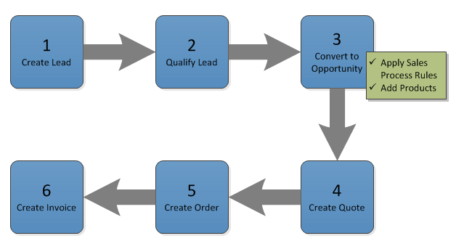

Considering this diagram, we can see how the natural progression of a qualified lead is to spawn new records; in particular an opportunity. Looking back at the default sales pipeline included with Dynamics CRM, and considering the relationship between Lead and Opportunity, we can conclude that the first stage of the pipeline (**Qualify**) is handled by the Lead entity. In the sales pipeline proposed by ACME, the first stage of the pipeline handled by the Lead entity is named **Suspect**.

At the core of our sales process we have the opportunity record, which represents the remaining stages of the sales pipeline for the organization. In other words, an opportunity represents potential revenue from a registered client (a client can be an account or contact). Opportunities can be linked to other types of records, such as:

* **Originating Lead:** The lead record that originated the opportunity (if applicable).
* **Competitors:** Who are we competing with in this sale?
* **Stakeholders:** Who are the stakeholders (e.g.: influencers, decision-makers and other connections) for this opportunity.
* **Sales Team:** New to Dynamics CRM 2013, this grid allows the user to specify other system users as part of the sales team to whom they can share the opportunity record with.
* **Products:** What are we intending to sell.
* **Contact:** The person who we are selling to, either as the direct consumer, or the contact within the organization we are trying to sell to.
* **Account:** The organization we are trying to sell to.
* **Potential Client:** The account (organization) or contact (person) to which we are trying to sell to. In Dynamics CRM 2013, this field is not displayed in the opportunity form by default and its value the value of this field is automatically defined as follows: If a contact has been specified but no account has been specified, the system will consider this a business-to-consumer opportunity and therefore will set the contact as the potential client. However if an account has been specified (even is a contact has also been specified), then the system considers this a business-to-business sale and therefore the potential client will be set to that account.

**Tutorial: Learn 4 ways to put campaign responses to work for you:**

<http://www.microsoft.com/dynamics/crm/content/RC/2011/en-us/online/5.1_CTP/campaignresponses.aspx>

A lead entity represents an individual that is identified as someone who is interested in receiving specific information about the products or services offered by the company. The information is provided to a lead by a salesperson through email or other communication activities available in Microsoft Dynamics CRM. A lead is used to track contacts or accounts that are potential customers, but who have not yet been qualified.